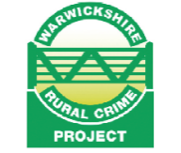

MEETING & INFORMATION EVENING
FOR
ALL FARMERS, HORSE OWNERS & RURAL BUSINESSES
on
WEDNESDAY 6TH MARCH 2019
7.00 to 9.00PM
at
Broadstreet Rugby Football Club
Ivor Preece Field
105 Rugby Road
Binley Woods
CV3 2AY.
Attending for you to speak to will be:
Police & Crime Commissioner for Warwickshire
Inspector for Rugby Area Local Policing Team and local beat officers
Police Crime Prevention Officer with information and displays on the latest crime prevention equipment available
Rural Crime Officer & Wildlife Crime Officers
NFU
Representatives from Warwickshire County Council, Rugby Borough Council, Fire Service & Large Animal Rescue Team, Trading Standards, Warwickshire Horse Watch, Cyber & Business Crime Advisors, NHW and many other supporting organisations.

