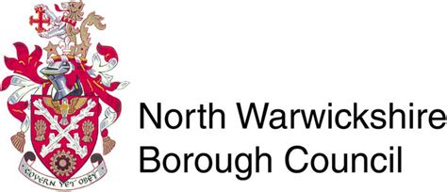
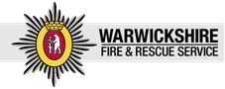

COMMUNITY ENGAGEMENT DAY
on
SATURDAY 25TH MAY 2019
10.00AM TO 2.00PM.
In the
MARKET SQUARE
ATHERSTONE

Great Opportunity to come and chat with local agencies to get advice and information, including:
Local police officers re advice, discuss any issues or concerns and information on crime prevention.
Fire service providing advice on fire and home safety.
North Warwickshire Neighbourhood Watch with information on their group and crime prevention equipment for sale.
North Warwickshire Borough Council re services available.

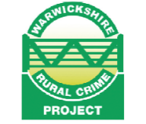
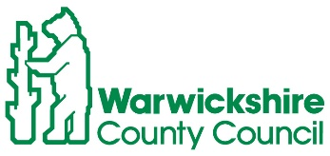
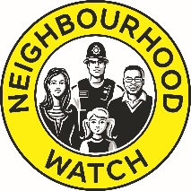
Property marking pens and purse bells will be available to everyone who attends and van packs will be available for van owners.

