 **North Warks West & South Safer Neighbourhood Team Newsletter**

Follow us on Facebook, Search for Atherstone & Coleshill Safer Neighbourhood Team

November 2021

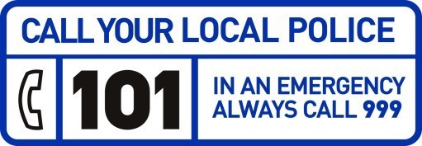

Arrest Made at Local Car Boot Sal

**A female was arrested after being seen with a group of persons acting suspiciously at a car boot sale in Furnace End.**

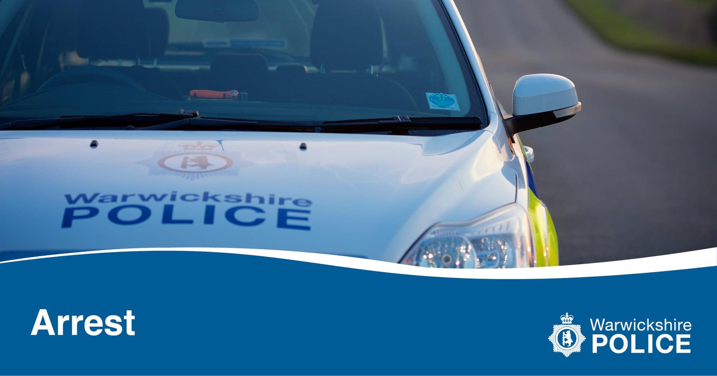

A member of the group requested access to victim’s vehicle to look at some clothing inside and other members of the group were in close vicinity. The stall holder allowed access and was distracted by others persons in the group.

The victim has noticed her purse and IPad had been stolen from vehicle and the female suspected to be part of the group and involved in the offence was arrested.

Please remain vigilant if are attending any events of this nature.



**If you would like to set up your own village speed watch team or join an existing team then please get in touch with your local Safer Neighbourhood Team**

[**nww.snt@warwickshire.pnn.police.uk**](mailto:nww.snt@warwickshire.pnn.police.uk)

**Or**

**nws.snt@warwickshire.pnn.police.uk**

Jailed in Warwickshire

**#JailedInWarwickshire**

**Zoe Jenkins has been jailed for 36 weeks after she viciously assaulted a woman in Gun Hill.**

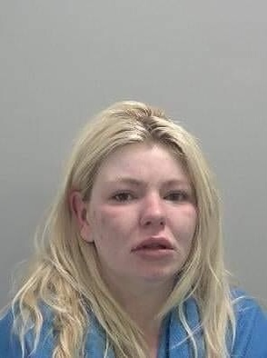

Jenkins was heavily intoxicated when she launched the attack in April.

North Warwickshire Safer Neighbourhood Sergeant, Adam Skelsey said: “This was a cowardly attack. Thankfully, the victim’s injuries were not as serious as they might have been.

“Jenkins showed no remorse throughout this case and put the victim through the ordeal of a trial.

“Warwickshire Police will not tolerate this kind of offending and will do everything in our power to bring offenders to justice.”

<https://bit.ly/3ap7bw8>

Male Sentenced Following Kingsbury Chainsaw Incident

**A male has been jailed for brandished a running chainsaw while shouting threats in a car park - and the whole thing was caught on camera.**

Despite the frightening scene in north Warwickshire being captured on a mobile phone, Charles Pugh at first denied possessing a bladed article - the chainsaw - in public.

He later changed his plea at Warwick Crown Court to guilty and was jailed by a judge who told him that the petrol-powered chainsaw is a "highly dangerous weapon" which "could dismember someone very quickly".

Pugh, 37, also admitted failing to provide a breath specimen after driving away from the scene, was jailed for nine months and banned from driving for two years and three months.

Prosecutors said that at just before midnight on February 24 the police received a call to say two men were fighting on the car park of Jubilee Court in Kingsbury.

One caller described a male as "aggressively drunk", who got a chainsaw from his car and started it up as he continued to make threats towards the other man.

The witness recorded the incident on his phone, but Pugh left in his car before police arrived.



Jailing Pugh, Judge Lockhart told him: "You got very drunk when you went to collect a chainsaw.

“You argued and got angrier and angrier, and when you got the chainsaw you were told it was not working and in a fit of pique and anger you started it up, and you were then waving it around in a public place, causing fear.

“It is a highly dangerous weapon. A started chainsaw could dismember someone very quickly, and you were under the influence of alcohol, which is an aggravating factor.

"I am absolutely clear that when someone is running around with a chainsaw in a public place this can only be met by a custodial sentence which must be served immediately.”

**Coleshill Safer Neighbourhood Teams have been out and about in October engaging with our communities and offering crime prevention advice**

We attended Ansley Common allotments for a property marking event and we were able to mark numerous amounts of property for the allotment and local residents. It is important to mark items of value with a house number and a postcode. They can then be traced back to an owner in the event of them ever being stolen and recovered.

We have also visited Shustoke Reservoir, Coleshill. We were happy able to register a number of bikes and crime prevention advice was also provided to numerous locals and visitors. We also gave out bike accessories which has been provided by Warwickshire Road Safety Partnership.

We would also like to thank Neighbourhood Watch who had attended the event and we will continue to arrange further community engagement events.

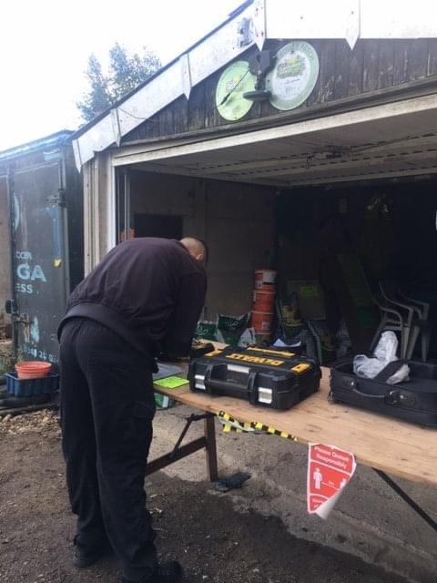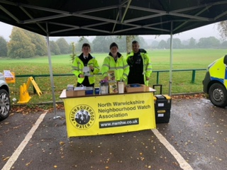

Despite the weather today the North Warwickshire South team held a property and bike marking event at the leisure centre in Arley with North Warwickshire Neighbourhood Watch and North Warwickshire Police Cadet Jake.

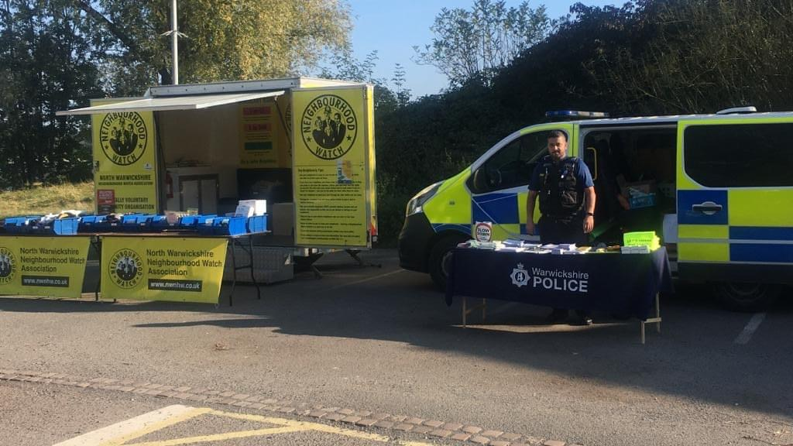

**Thanks to those who attended.**

Keep an eye on our Facebook page for future events….

If you would like us to visit you at your allotment, business, village hall or village then get in touch with your local team.

**Email us at:**

[**nww.snt@warwickshire.pnn.police.uk**](mailto:nww.snt@warwickshire.pnn.police.uk)

**Or**

**nws.snt@warwickshire.pnn.police.uk**

Community Engagement Events

Our Road Safety Campaign Continues

**Officers have attended Coleshill High Street and issued a male a formal police community protection notice in regards to issues outside Costa Coffee.**

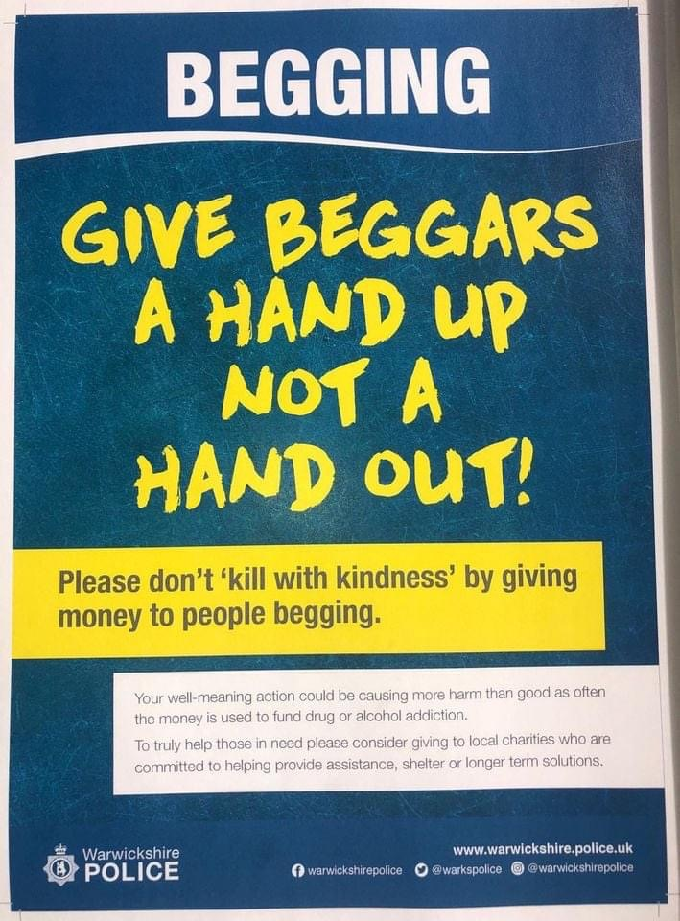

This is after complaints from local shops and members of the public in regards to begging, loitering and intimidation.

The male in question has been offered support services but has so far refused to engage. If the male continues with his behaviour then he may find himself liable to a fine or arrest.

We are also asking members of the public to support a local relevant charity instead of financial reward for the individual.

We know people want to help (we do as well) but unfortunately this is contributing to some of the complex issues.

Community Protection Notice Issued in Coleshill

**Throughout October we have continued to target speeding drivers, illegal vehicles and inconsiderate parkers in a bid to keep our roads safe**

These cars were seized in Bodymoor Heath when they were found to be uninsured and one driver had no drivers licence.

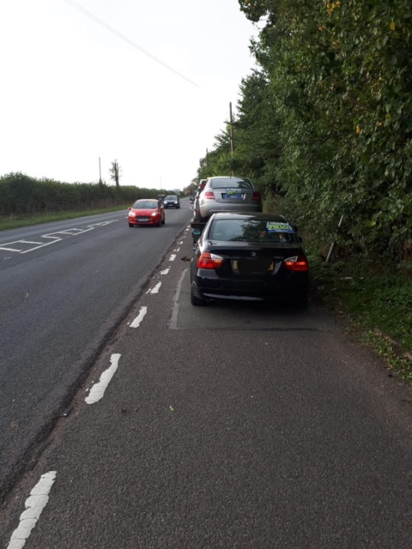

We have continued to carry out enforceable speed checks at various locations at the request of residents and local Parish Councils.

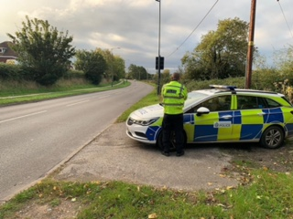

We have also been visiting schools within our beat area to promote safer parking.

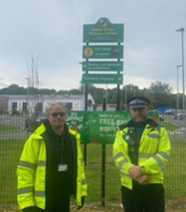

## Welcome to Warwickshire Connected

**Get connected with what is happening in your local area, keep up to date and get involved in shaping what goes on where you live or work.**



Warwickshire Connected is a free messaging service brought to you by Warwickshire Police where you decide when and how you hear about the issues that matter most to you, whether that be getting regular crime updates, the latest information on ongoing incidents and emergencies or learning more about what your local police are doing.

This is also the place where you can get involved in helping to make your local area a safer place, tell us what police should be doing in your area, shape the initiatives that help to keep people and property safe and tell us what matters are causing your communities harm.

**(Text - Trends)**

**(Image)**

**Text)**

Great work by our Traffic Colleagues

Tackling Off-Road Motorcyclists

**As part of a very busy weekend and as well as attending engagement events to talk to our residents and offer crime prevention advice, members of the North Warwickshire West Safer Neighbour Team out and about in North Warwickshire tackling illegal off road motorcyclists.**

**The photograph below shows just a few of the locations we visited following calls from members of the public**

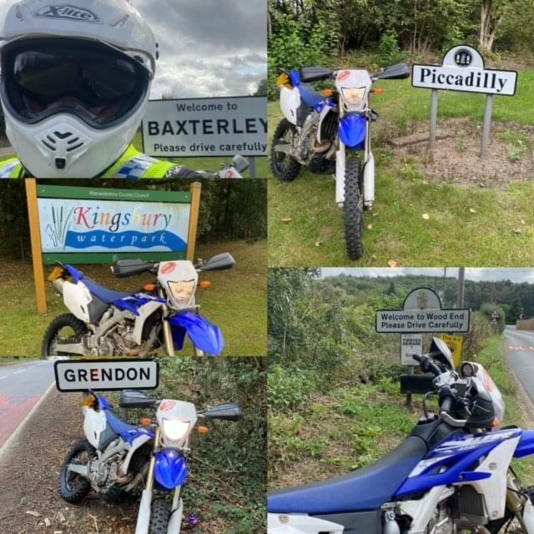

Officers also attended Daw Mill Colliery after reports of issues in the area. The police drone was deployed and a large gathering of bikes were observed.

Five people were detained by officers who were from the Coventry and Walsall area. We have pictures of the others involved and investigation is ongoing

We can all appreciate the difficulties farmers face in growing a successful crop yield. Adverse weather conditions, crop disease, staff shortages to name but a few.

If that wasn’t enough, Off Road vehicles and motorbikes being driven through crops can scrap that whole yield through damage costing farmers and land owners thousands of pounds.

Our message is simple: If people choose to trespass onto farmers’ fields or land belonging to others without their permission then they may be committing Criminal Damage which may lead to arrest and charge….not to mention having bikes or vehicles seized. Our Police riders do not go through crops causing damage and have the permission of land-owners to be there as it usually the land-owners who call us for assistance.

**Following great work by our colleagues on the Roads Policing Team, four persons were arrested in the early hours on a day in October after acting suspiciously near to parked lorries at Hams Hall, Coleshill.**

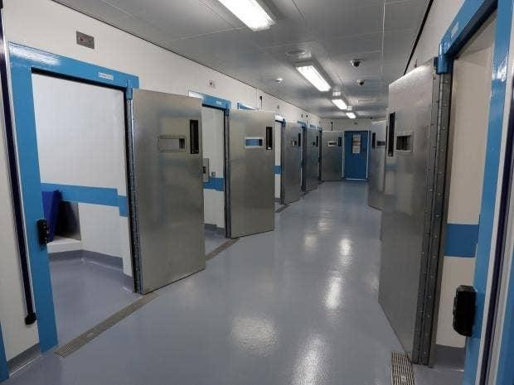

Officers later identified two lorries had been interfered with at the location and persons in custody suspected of being involved in the offence.

The suspects, who gave addresses in the north of England were interviewed and enquiries are still ongoing with reference to the incident.

The officers were proactively patrolling the industrial park following reports of suspicious activity over the previous few days

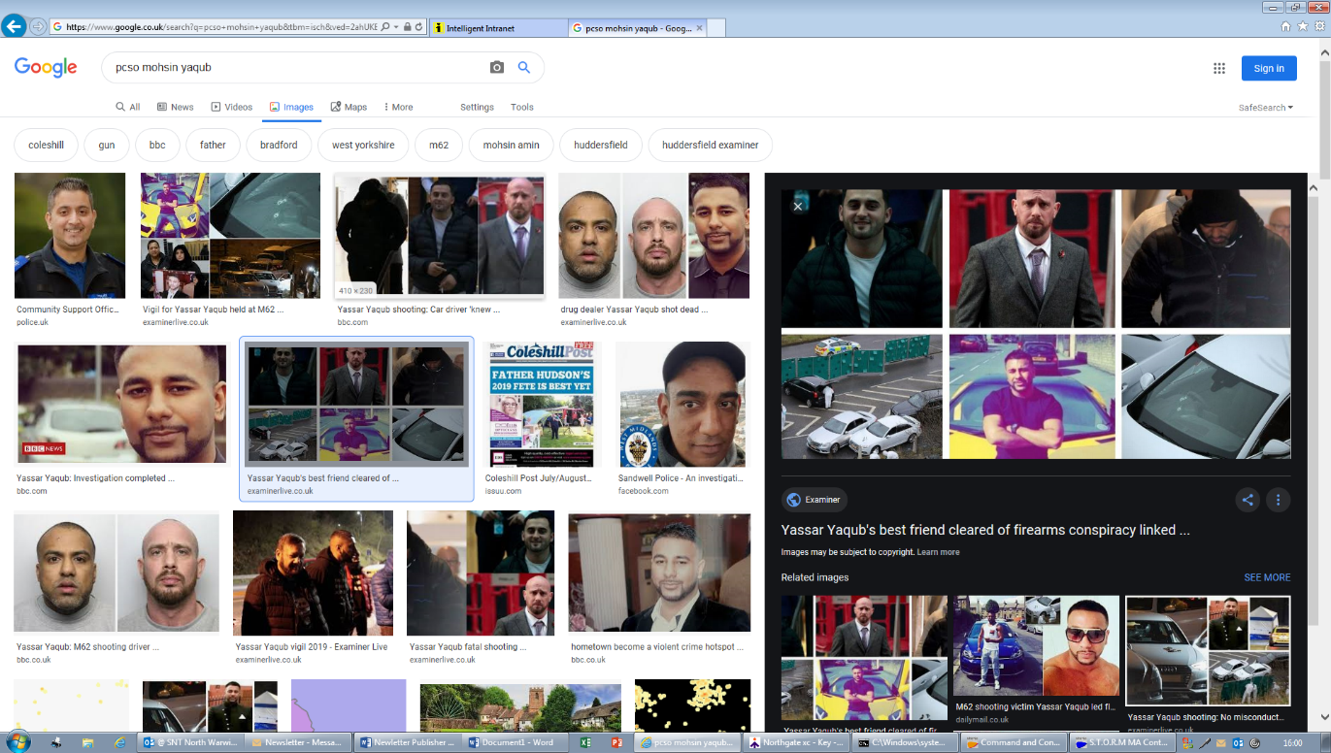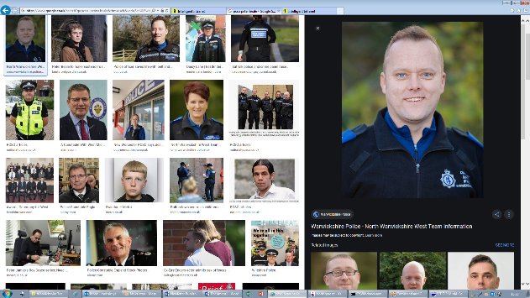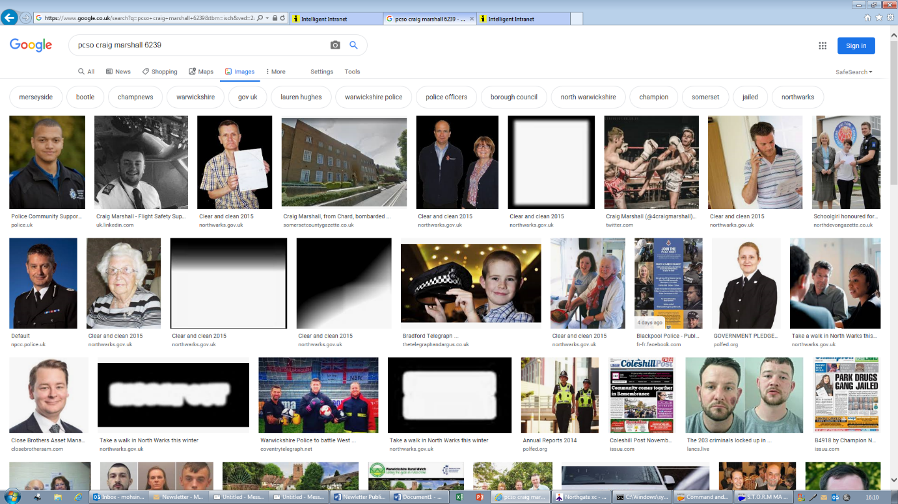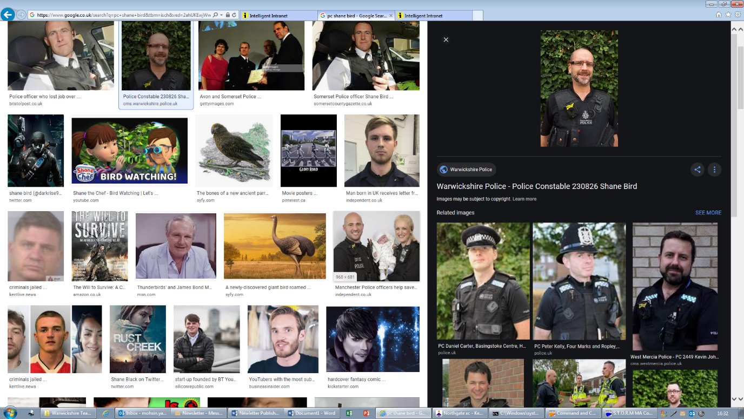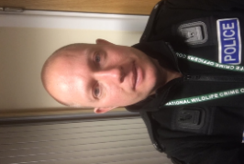



PS 671 PCSO 6280 Adam Skelsey Mo Yaqub

PCSO 6067 Peter Beale

**North Warwickshire West and South Safer Neighbourhood Teams**

PC 826 PCSO 6239 Shane Bird Craig Marshall

PC 1464

Simon Ackroyd

**Email:** [**nww.snt@warwickshire.pnn.police.uk**](mailto:nww.snt@warwickshire.pnn.police.uk)

**Or**

**nws.snt@warwickshire.pnn.police.uk**

**Our Partners**

